Name:

Matric

Course:

**Query for Course with the least number of student Enrollment**

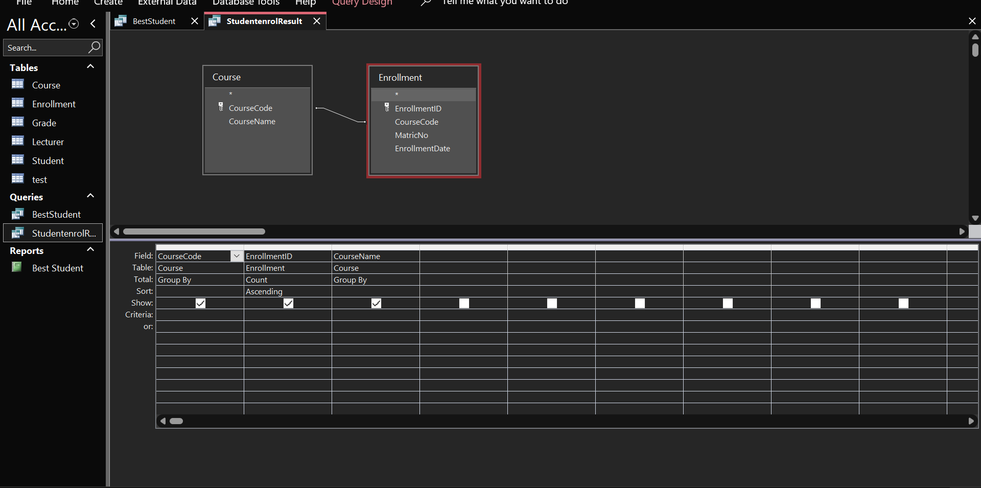**Design View**

**Datasheet View (Output)**

Name:

Matric

Course:

**Query for Best Student in COM 312**

**Design View**

Datasheet View (Output)

